gbst_logogbst_logo

GBST DCA Database Registry Changer Utility User Guide1

This document provides a brief overview of the utility and what it does and serves as a guide on how to use the utility.

The utility provides an easy way to change the DCA database connection strings in the Windows registry to point to a different DCA database server.

****Note:**** This utility applies changes on DCA registry entries in the Windows registry. GBST advises caution in using this utility, as this may cause damage to the Windows registry and can potentially leave your machine in an unusable state. All precautions such as taking backups including but not limited to registry backups, disk images or other backup forms must be done before using this utility.

## Software Prerequisites

The utility is dependent on the .NET Framework version 4.5.2. Download the framework from <https://www.microsoft.com/en-au/download/details.aspx?id=42642> and install it.

## Usage

To use the utility, do the following steps:

1. Unpack the utility package to a location in your computer.
2. Right-click on “RegDBChanger.NET.exe” and click on “Run As Administrator”.

****Note:**** The user should have administrator rights on the computer.

The utility window will now be displayed.

1. On first time use, the default DCA database server value in the registry will be displayed in the DCA Database Server dropdown.

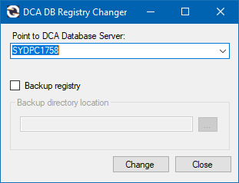

Double-click on the dropdown field and enter the new DCA database server to point to. Valid database server values can be one of the following:

1. The database server name only (e.g. “SDC-DCA14”)
2. The database server name and the port number for the database instance (e.g. “SDC-DCA14, 1455”)
3. The database server name and the actual database instance name (e.g. “SDC-DCA14\SQLEXPRESS”)
4. To take a backup of the current DCA registry settings before making the change, tick on “Backup registry”. Browse for the directory location to store the registry backups. Alternatively, directly enter the location in the directory location field.

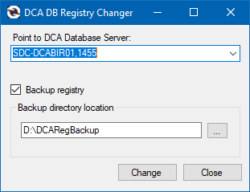

1. Click on “Change” button to change the DCA registry entries to point to the new DCA database server specified. If the “Backup registry” option is ticked, the original DCA registry entries are saved in text files in the specified directory location. The new database server entry will be saved as an available option in the dropdown. Up to 10 database entries can be saved, and these will be retrieved and available from the dropdown field the next time the utility is used.
2. If DCA registry backups were taken and you want to restore them, browse to the directory where the registry backups are located. Rename the filename extension of the backups from “.txt” to “.reg”. Double-click on each file to merge the entries into the Windows registry, overwriting the current DCA registry entries.